|  |  |
| --- | --- |
| **SPRINT-1** | |
| Team ID | PNT2022TMID37201 |
| Project Name | Project - IoT Enabled SMART FARMING  Application. |

**REGISTRATION:**

Register for the application by entering my email and create password.

**Welcome Screen:**

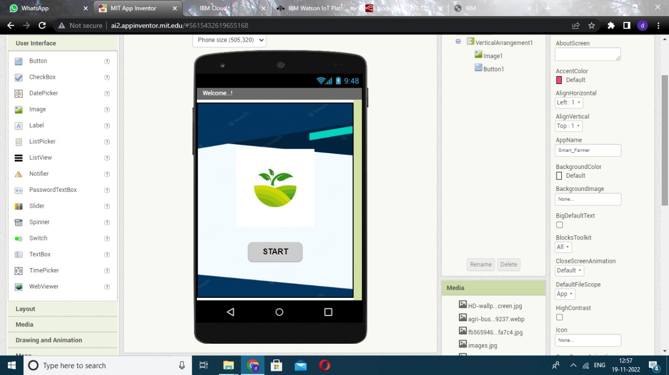

**Registration Tab on MIT App Inventor:**

**Sign in\ sign up page will appear**

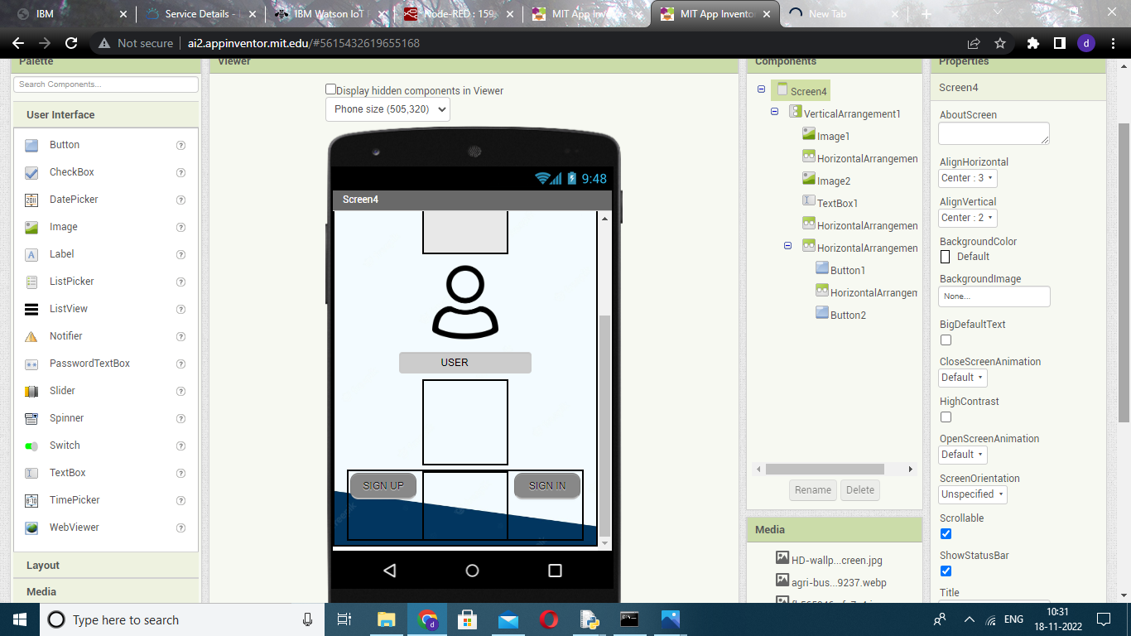

**SIGN UP PAGE :**

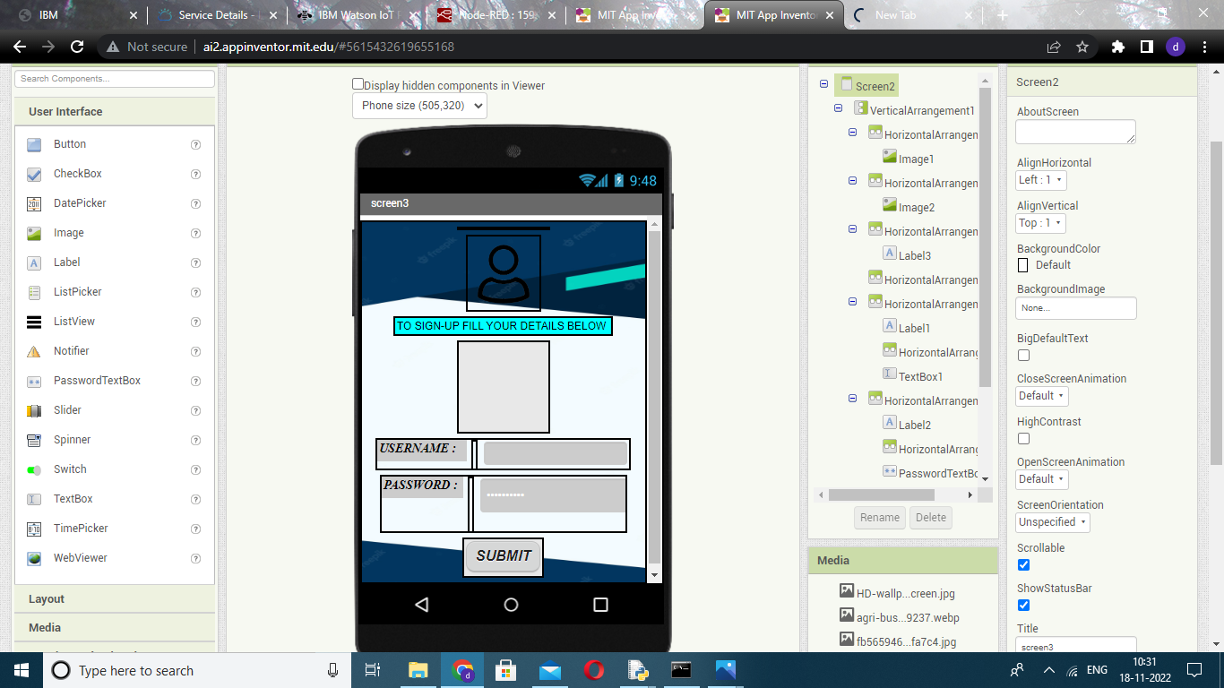

**START TAB:**

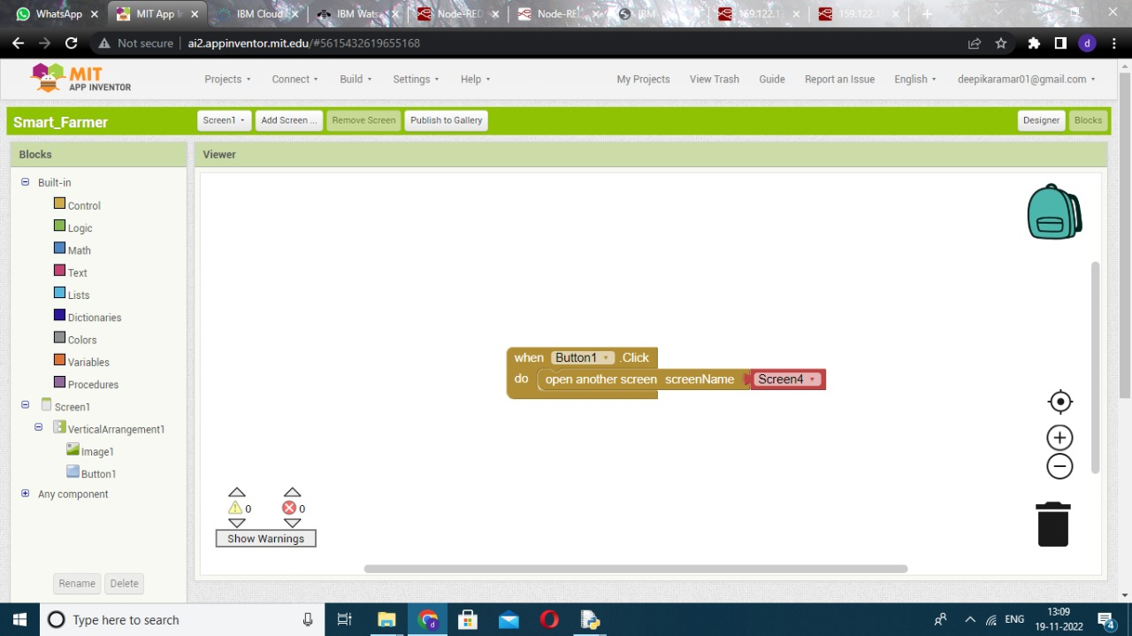

**SIGN UP/SIGN IN :**

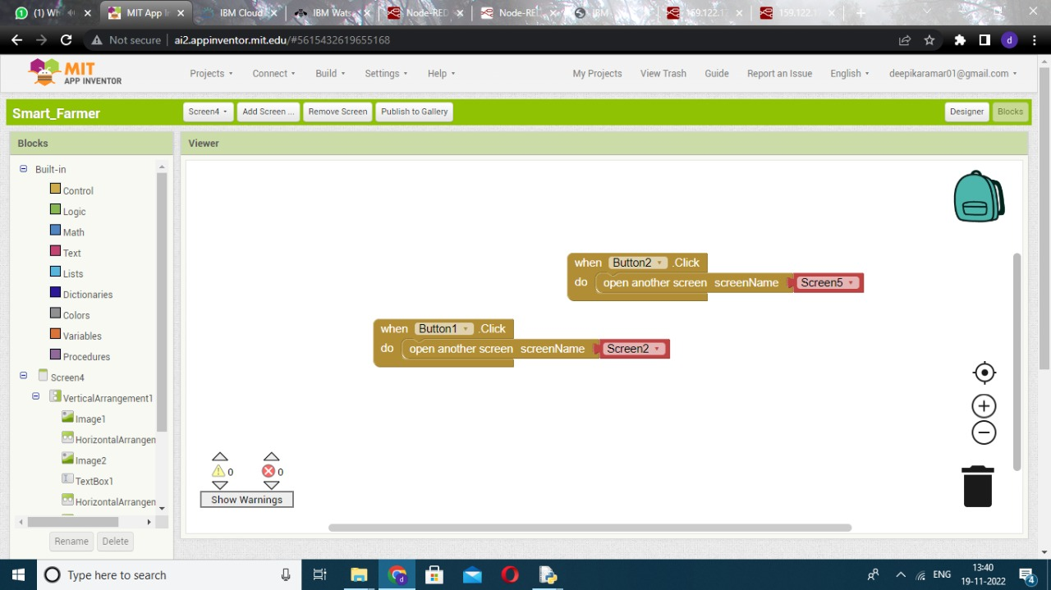

**New Registration Tab:**

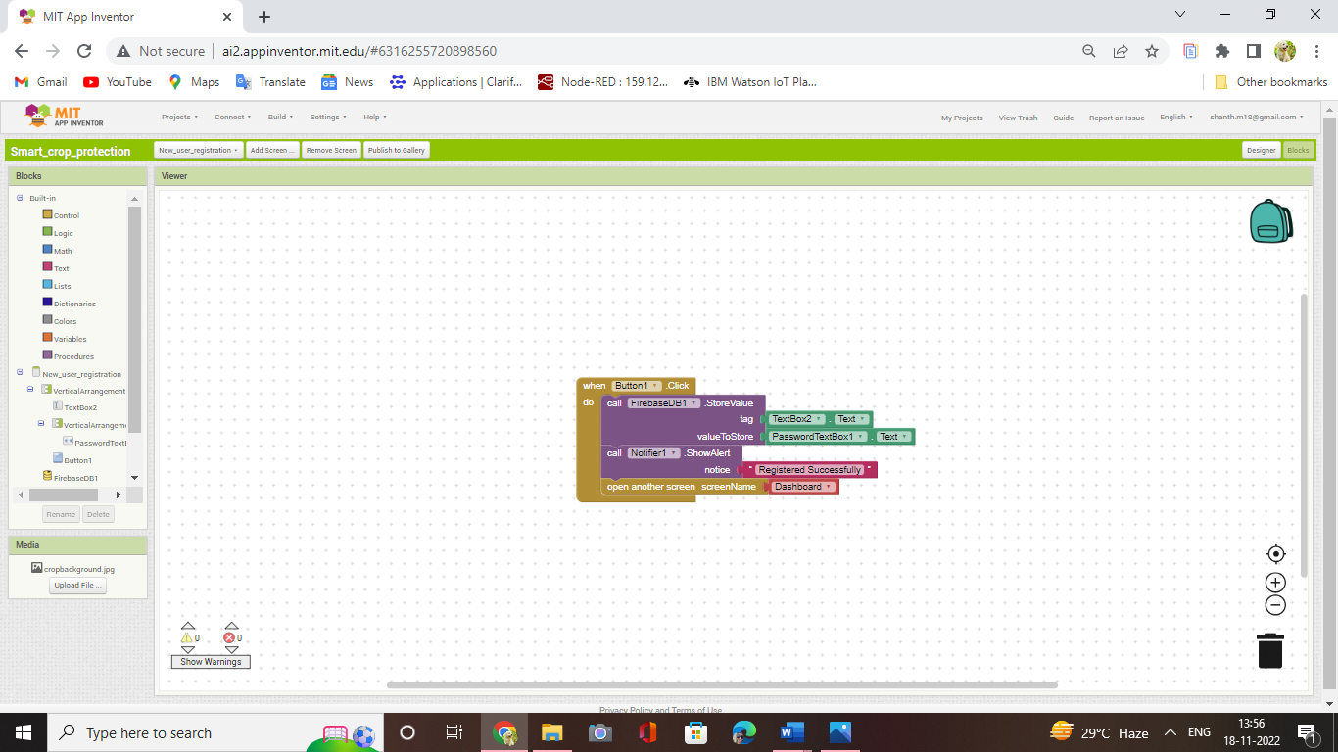

**Firebase database to save email and password:**

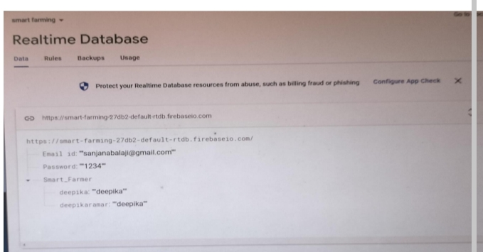

**Blocks of Login Page:**

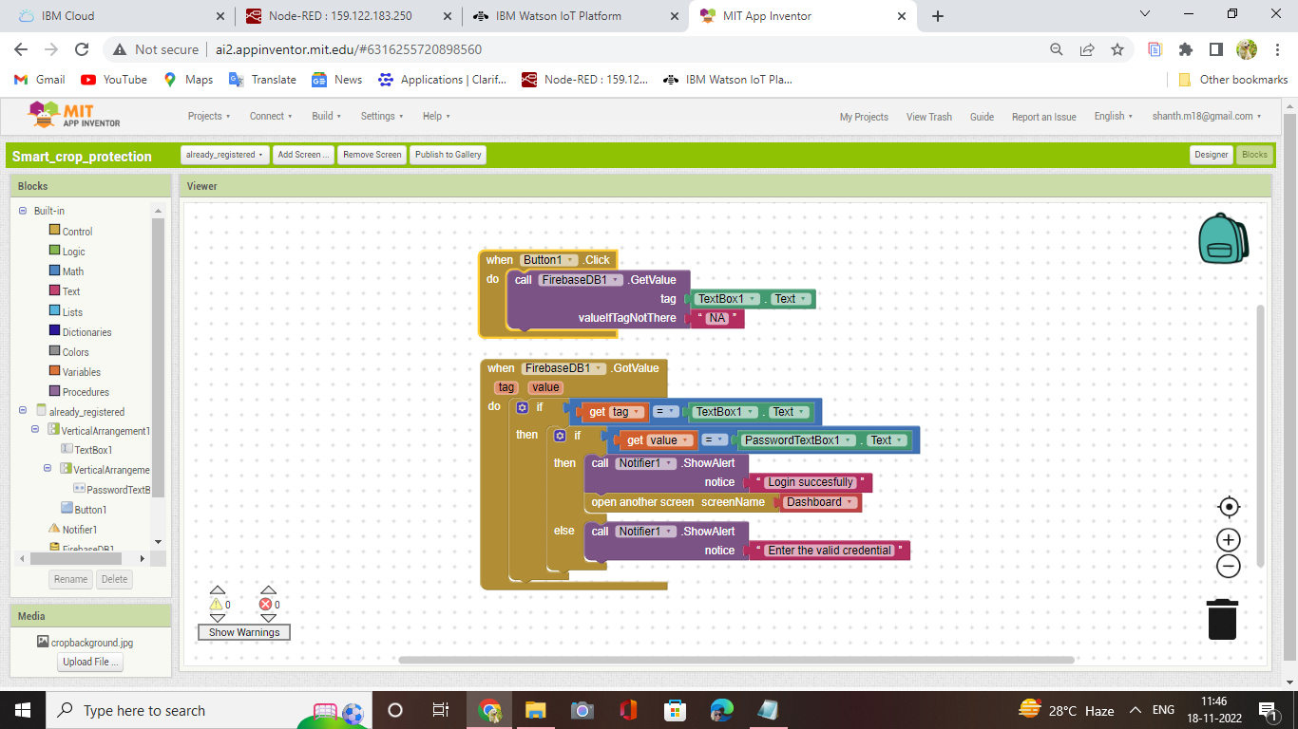

The email and password are verified by firebase database that we used during sign up.